Loch Lomond School Student Handbook
25 Evergreen Avenue
Saint John, New Brunswick
E2N 1H3

Mission
Our mission is to foster scholarship, leadership and responsible citizenship / Notre mission est de favoriser l’érudition, le leadership et la citoyenneté responsable.
Vision
Loch Lomond School endeavors to know each child’s strengths and challenges, and to adjust the learning to this end / Loch Lomond School s’efforce de connaître les forces et les défis de chaque enfant, et d’ajuster l’apprentissage à sur measure.
Bell Schedule
7:50 am Morning supervision begins.
8:15 am Homeroom
8:30 am Classes begin - Students tardy following

10:00 am 3-5 Recess
10:15 am K-2 Recess
10:30 am Classes resume

12:00 pm 3-5 outside and K-2 Lunch
12:20pm K-2 Outside and 3-5 Lunch
12:45 pm Classes resume

1:45 pm K-2 Dismissal
2:45 pm 3-5 dismissal

Arrival / Dismissal Routines
For the safety of our students, we are reminding parents and guardians that when they are dropping off their child/children to drop them off in the roundabout– just in front of the school. (This avoids you from entering the school yard where the buses are arriving). If you are picking up your child afterschool, please park in the designated parking area or on Evergreen Avenue and walk to the back of the school where students are being dismissed.
When coming into the school to pick up a child or to drop something off – again park your car and come into the school office. A reminder - the speed limit in the school area is only 30 km /h and parents should slow down even more when approaching the school yard.
- Visitors to the school must sign in at the Office.
- Loch Lomond School is a “Scent Sensitive” school.
- Loch Lomond School is a “Nut Free” school.
- Please sign out your child if you are taking them out of the school during regular school hours (A written note is helpful to teachers so that they are aware.).
- It is important that you meet your K-2 child at the bus stop. The bus driver will not let students off unless there is an adult to accept them.

Code of Conduct
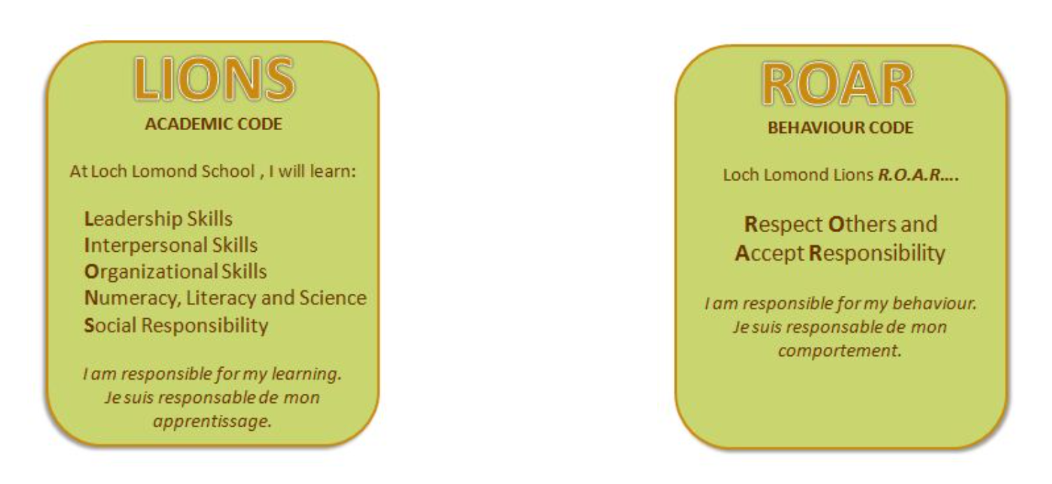
Playground Loch Lomond School
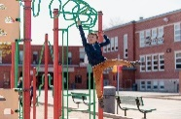
Playground Boundaries
This Photo by Unknown Author is licensed under CC BY-SA-NC
Roary’s Prideland

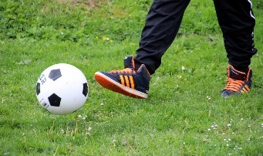

- All students are to go outside at recess and lunch break. During cold or wet weather, students will remain
inside.

2.) Students will respect others, their property, and personal belongings.

3) Some equipment will be closed in the winter (including the hang glider) due to icy conditions

4) In the winter, students must slide down hills on their bum in ski pants and should remain off icy surfaces or
snowbanks

5) General playground rules

- Keep your hands and feet to yourself
- Play safely on the equipment
- Use appropriate language
- Take turns
- Respect the playground boundaries and ask permission if you need to go out of bounds
- Rocks, apples, and snowballs stay on the ground
- Include others in your games
- Climb UP the Rock Wall
- Slide DOWN the slides only and move away quickly once down.
- Keep lines moving on the equipment.
- Play on it – only if you can reach it
- The spider net and monkey bars are used for swinging / climbing only.
- Tag games are to be played in the field, bus turn around or at safe distance from the equipment.
- Balls are for the field or pavement

6) When lined up, quiet students will enter the school in an orderly fashion.
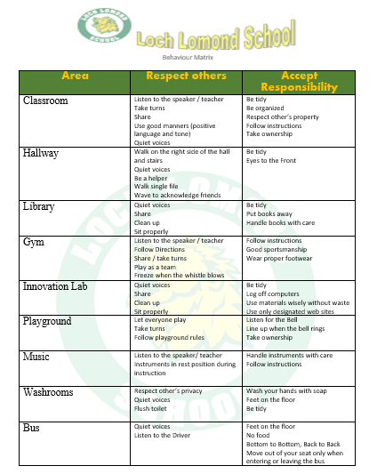

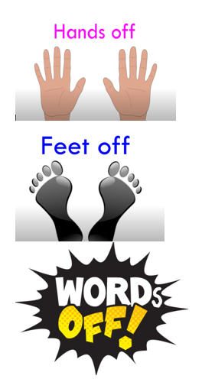
Busing Guidelines
Bus Safety

1.) Be on time and never stand on the street or road while waiting for the bus.
2.) Speak quietly when the bus is in motion.
3.) Students shall be picked up and discharged only at the bus stops approved by the district and school.
4.) Do not cross the road behind the school bus.
5.) Occupy seats assigned by the driver or principal.
6.) Do not throw anything on the floor of the bus. Help the driver keep the bus neat and clean.
7.) Eating and drinking are not permitted on the school bus.
8.) Be courteous to the driver and fellow passengers. Rough and loud conduct will not be permitted and will result in a bus violation being submitted to the principal.
Changes in Transportation

ASD-S Transportation Dept. states, “For safety reasons, PLEASE do not send requests to the school asking for your child to go on a different bus after school UNLESS it is an emergency or for an extended period of time.”
We CANNOT allow a child to go on a different bus because they want to go to a friend’s house after school. Parents/Guardians may request to have their child/children delivered to an alternate address.
Students MAY be permitted to travel to an alternate address providing all of the following conditions are met:
- a “Request for Alternate Transportation” form, with parent/guardian’s signature is submitted through the ASD-S website.
- The service requested is to be applied consistently to the same locations and o the request can be accommodated by an existing route and stop; and
- the school bus has space for extra passengers.

Evacuation Procedures
In accordance with the Superintendency Emergency Preparedness Plan, we would like you to be aware that every possible precaution is being taken to ensure the safety of your child. We are cooperating with local authorities, Anglophone South School District, and the Emergency Measures Organization in this activity.
Our school has prepared a Comprehensive Safety Plan that is designed to safeguard your child against emergencies and disasters. In the event of an emergency with sufficient warning, children will be sent home. In some emergencies, it will be best to retain the children and seal the building to ensure safety. If, on the other hand, we need to evacuate the building, then we will go to the Saint John Airport.
It is very important that we have access to our telephone lines to communicate with emergency services. If there is an emergency – please do not contact the school. We will convey all necessary information to you by Talk Mail, Twitter (which is on the website too) and through the local radio stations. Also, we would need to keep the driveway in front of the school free for emergency vehicles and for school buses.
It is our hope that a disaster will never occur; however, the implementation of the Comprehensive Safety Plan will ensure the health and safety of your child under all anticipated emergency conditions.
Communication
There is an abundance of information found on our school website and on teams. We encourage families to become familiar with it. The link is http://web1.nbed.nb.ca/sites/district8/schools/lochlomond/Pages/default.aspx
Additionally, we frequently like to showcase and celebrate student learning and engagement through our Twitter page. Please follow us! Our twitter handle is @LochLomondNB
We welcome any suggestions you may have or information you’d like to see highlighted through our social media platforms.
We also send weekly voicemails to parents, and monthly newsletters outlining upcoming events.

Inclement Weather
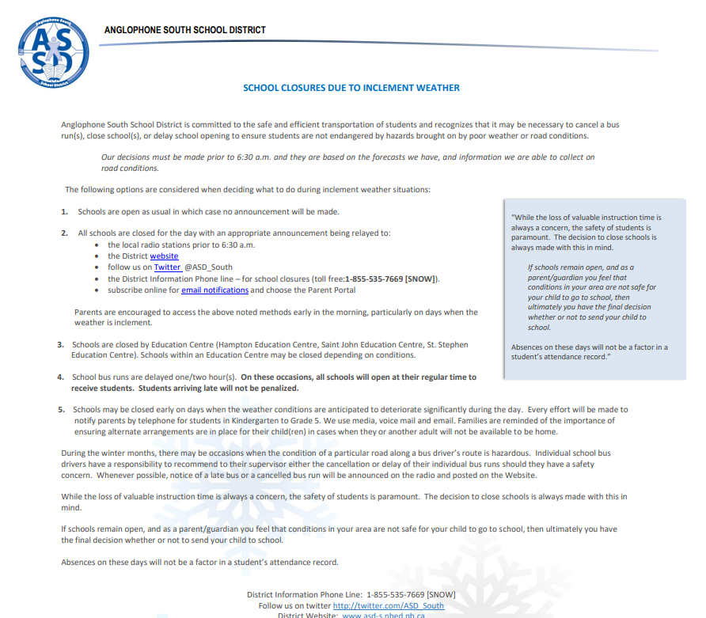
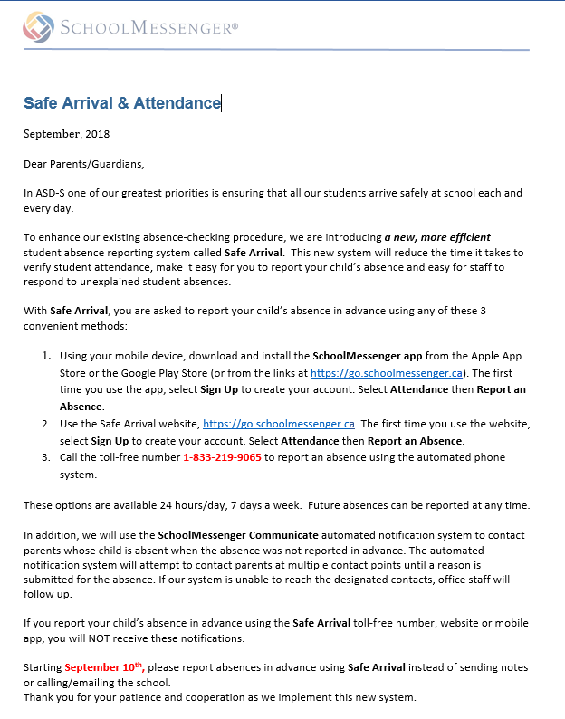

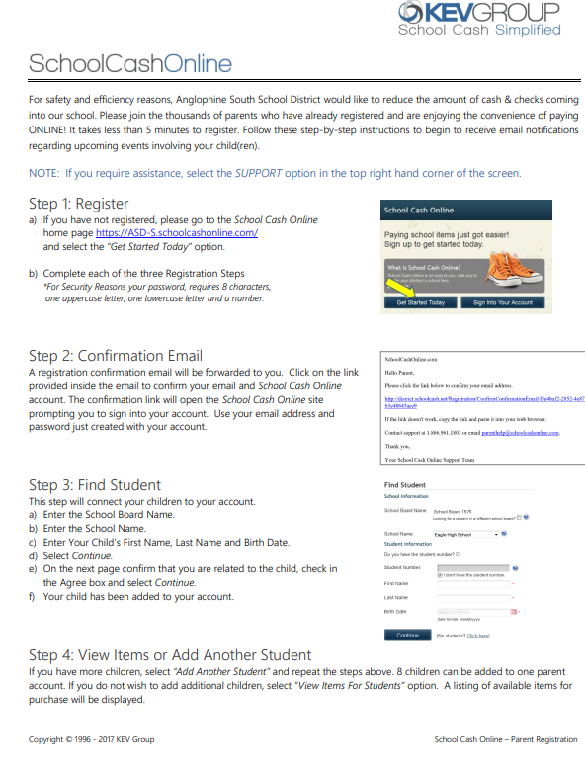
School Cash Online

WITS Program
Loch Lomond School will be again using the WITS anti-bullying program this year. Here is an article to explain some of the concepts that will be covered:
WITS FAQ

What are the WITS Programs?
The WITS Programs bring together schools, families and communities to create responsive environments that help children deal with bullying and peer conflict. WITS has two parts:
- WITS Primary Program – Teaches Kindergarten to Grade 3 children to Walk away, Ignore, Talk it out and Seek help when faced with peer conflict. The acronym also provides a common language that children and the adults around them can use to talk about and respond to problems.
- WITS LEADS Program – A more grown-up program designed for Grades 4-6 students, which teaches more complex problem-solving strategies: Look and listen, Explore points of view, Act, Did it work? and Seek help. LEADS trains students to become WITS Leaders who can help younger children with their problems.
Teachers reinforce the programs by reading popular children’s books, which emphasize WITS and LEADS messages, to their students. We also encourage students to use their WITS and LEADS skills to deal with problems and hope you will too!
Want to know more? Explore the WITS website at www.witsprogram.ca.

How can I help my child use WITS to solve problems?
Your child can likely recite the WITS acronym but may need help putting it in action. Use the tips below with your child to explore how WITS can help with peer conflict problems.
- Walk away: Role-play walking away from the situation. Ask: What would happen if you walked away? Would it solve the problem? If not, try another strategy.
- Ignore: Discuss ways to ignore, like leaving the situation or withdrawing eye contact. Ask: What would happen if you ignored? Would it solve the problem? If not, try another strategy.
- Talk it out: Suggest statements to use to talk it out with the person bothering him or her. Sometimes saying “Stop” is enough. Maybe a joke would help. Ask: What would happen if you talked it out? Would it solve the problem? If not, try another strategy.
- Seek help: Suggest other adults your child could ask for help, like a teacher. Ask: What would happen if you asked another adult for help? Would it solve the problem? If not, who else could you seek help from?
Want to know more? Explore the Using WITS with Your Child section of the WITS website at www.witsprogram.ca/families/using-wits-with-your-children/.

How can I get my child talking about peer conflict and bullying?
When it comes to talking to your child about peer conflict and bullying, once is not enough. Children need multiple opportunities to learn information and apply it in their lives. So how do you start the conversation?
- Children may feel their situation is unique and that you wouldn’t understand. Share a story about how you were teased or left out as a child. What did you do? Did it work? Who helped you?
- Pick a book from the WITS book list at www.witsprogram.ca/schools/book-lists/, read it with your child and start a discussion. What WITS or LEADS strategies did the characters use? Did the book remind you of anything similar that has happened in real life?
Sometimes the best way to get your child talking is through teachable moments. When watching TV or movies, talk about characters’ actions and how they resolved conflicts. When your child experiences conflict with a sibling or a friend, ask which WITS strategies might help.
Want to know more? Explore the Using WITS with Your Child section of the WITS website at www.witsprogram.ca/families/using-wits-with-your-children/.

How can I support WITS at home?
The WITS Programs are designed to reach beyond schools to protect children from peer victimization wherever they are. Parents play a critical role by teaching children to use their WITS in a variety of situations. So what can you do to support WITS at home?
- Use WITS and LEADS to help your child solve conflicts and deal with your own. Use the language when watching TV or movies to talk about how characters handle problems.
- Talk about WITS reminder gifts. Through WITS, community leaders visit classrooms and drop off gifts, such as bookmarks, pencils and posters. When your child brings home these gifts, ask: Who gave you this? What did the visitor talk about?
- Praise your child when you observe him or her using WITS or LEADS strategies. Ask: How did you decide which strategy to use? How did you feel when it worked?
Want to know more? Explore the Using WITS with Your Child section of the WITS website at www.witsprogram.ca/families/using-wits-with-your-children/.

Home / School Connections
Lost and Found
Lost and Found Elementary students tend to lose their belongings at school. Because many children have similar items, children can sometimes have difficulty identifying their own. Our Lost and Found area, which is in the breezeway, is often left with many unclaimed articles. If you label all of your child’s belongings, perhaps we can keep these losses to a minimum. We ask you to periodically check our Lost and Found area as we do donate items that are not picked up.
Communication
It is recognized that a good working relationship between the home and school can greatly benefit the child. The staff at Loch Lomond School want to encourage this type of relationship through communication in the form of newsletters, notes, and phone calls when needed. We also recognize that there may be a need for parents to meet personally with a teacher, and we encourage this. If a meeting needs to be scheduled, please contact the teacher to set up a time.
Parent School Support Committee
This is a support committee comprised of parents, community, teachers, Home and School, District Education Council, and the school Principal. Meetings are open to the public and the dates, times, locations and agenda are jointly prepared by the PSSC Chair and the Principal.
Home and School Association
Loch Lomond School has a Home and School Association. If you are interested in attending the meetings, please check the monthly newsletter for dates and times. Parent Volunteers – The school needs volunteers to ensure the continued success of programs and events such as fundraising, field trips, Fun Day, library, athletics, and Yearbook. Please discuss volunteering with your child’s teacher, the school, or your Home and School Association. Provincial policy requires that all volunteers in the public school system must have knowledge of Policy 701 (the Policy for Protection of Students) and present a validation form as well as a current police record check prior to volunteering at school. Parents who will be driving children to extracurricular events need to have $2,000,000.00 liability insurance, a criminal record check and a note from the parent of the child you are transporting. These forms are available at the office.
Homework
Homework provides students the opportunity to practice the skills they have learned at school. Parents can help by ensuring that students have a quiet work area. Bring homework supplies to the workplace and plan a homework time. If you are finding homework challenging for your child, please do not hesitate to contact your child’s teacher.
Personal items
We ask that personal electronics such as cellphones, IPODs, MP3 players or electronic games remain at home. We do not have lockers and things can go missing or get broken quite easily. Occasionally, teachers may request students bring to school a toy, book or a personal item pertaining to a school activity. Otherwise, please do not permit your child to bring toys or other valuables to school. Children who lose a favourite toy can become very upset. Sometimes a child lends a new toy to a friend and the toy becomes lost or damaged. Toys and valuable items are best left at home.

